LAB 1
HU22CSEN0100300
P.SUNANDITHA

WHAT IS GIT?

Git is a powerful tool for version control, especially in software development. It helps developers track the changes in their code and collaborate with others while maintaining different versions of a project.

Some of the important points about Git are mentioned below:

Version Control: Git allows the developers to save different versions of the code, and it's easy to revert to previous states if needed.

Collaboration: Many developers can work on the same project at the same time without overwriting each other's changes. Git merges these changes seamlessly.

Branching: Git supports branching, which lets developers create separate branches for new features, bug fixes, or experiments without affecting the main project. Once the work is complete, it can be merged back into the main branch.

Distributed System: Another thing unique to Git as compared with other versioning systems, is that Git is distributed. This allows each developer a fully independent copy of the entire history of the project, thereby enabling developers to work from anywhere and not have their Internet connection - and all the features that come along with version control, lost while doing so.

If you are interested in exploring further, I can guide you further through commands and workflows for using Git effectively.

WHAT ARE THE DIFFERENCES BETWEEN GIT AND GITHUB?
GIT | GIT HUB
A distributed version control system for tracking changes in source code. | A web-based platform that hosts Git repositories and provides collaboration features.
Manages and stores versions of your code locally. | Provides a centralized location for sharing and managing Git repositories.
A command-line tool. | A web-based interface.
Created by Linus Torvalds in 2005. | Created by Tom Preston-Werner, Chris Wanstrath, PJ Hyett, and Scott Chacon in 2008.
Stores data in a local repository on your computer. | Stores data in remote repositories on GitHub's servers.
Requires manual sharing of changes. | Offers easy collaboration and sharing through the web interface.
Primarily uses the command line. | Provides a graphical web interface.
No built-in issue tracking system. | Includes an integrated issue tracking system.
Does not have a pull request feature. | Allows users to submit pull requests for code review and merging.
Does not have a built-in community feature. | Provides a platform for open-source projects and community contributions.
No built-in CI tools. | Supports integration with CI/CD tools like GitHub Actions.
Free and open-source. | Offers both free and paid plans with additional features.
Can be integrated with various development tools. | Integrates seamlessly with Git and other tools like Slack, Trello, and more.
HOW TO CREATE PROFILE IN GIT

Setting up Git

1. Install Git: Download and install Git from the official website (https://git-scm.com/downloads) if you haven't already.
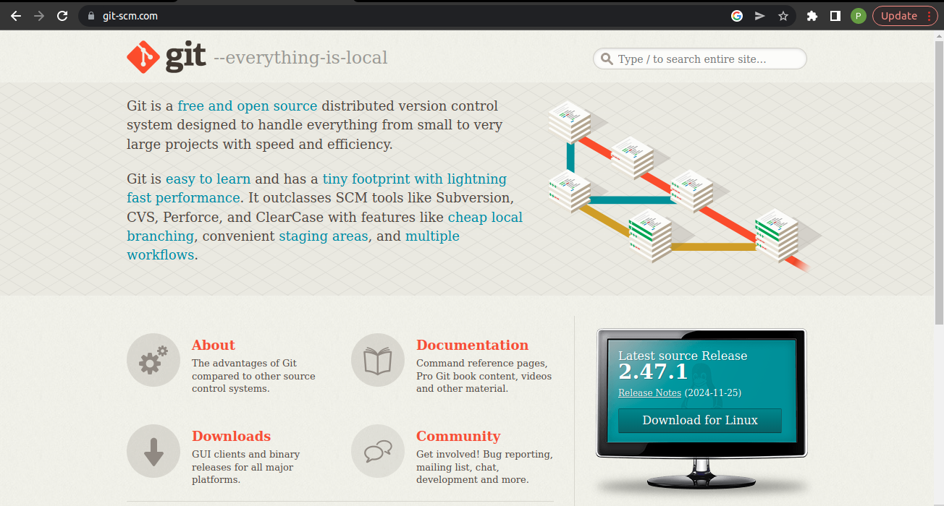

2. Open Terminal/Command Prompt: Open a terminal or command prompt on your computer.

Configuring Your Git Profile

1. Set Your Name: Type the following command to set your name:

git config --global user.name "Your Name"

Replace "Your Name" with your actual name.

2. Set Your Email: Type the following command to set your email:

git config --global user.email "your_email@example.com"

Replace "your_email@example.com" with your actual email address.

3. Verify Your Configuration: Type the following command to verify your configuration:

git config --list

This will display your Git configuration, including your name and email.

Creating a GitHub Profile (Optional)

If you want to create a GitHub profile, follow these steps:

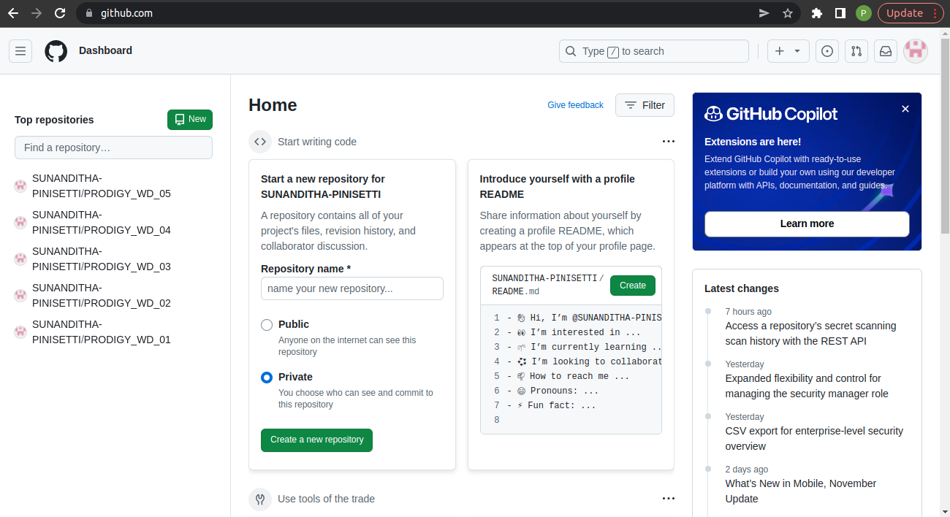
1. Go to GitHub: Go to the GitHub website (https://github.com/).

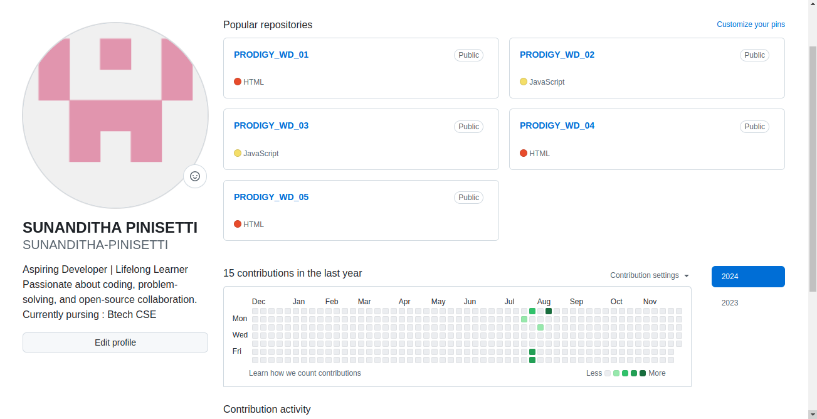
2. Sign Up: Click on the "Sign up" button and fill out the registration form.
3. Verify Your Email: Verify your email address by clicking on the link sent by GitHub.
4. Complete Your Profile: Complete your profile by adding a profile picture, bio, and other details.
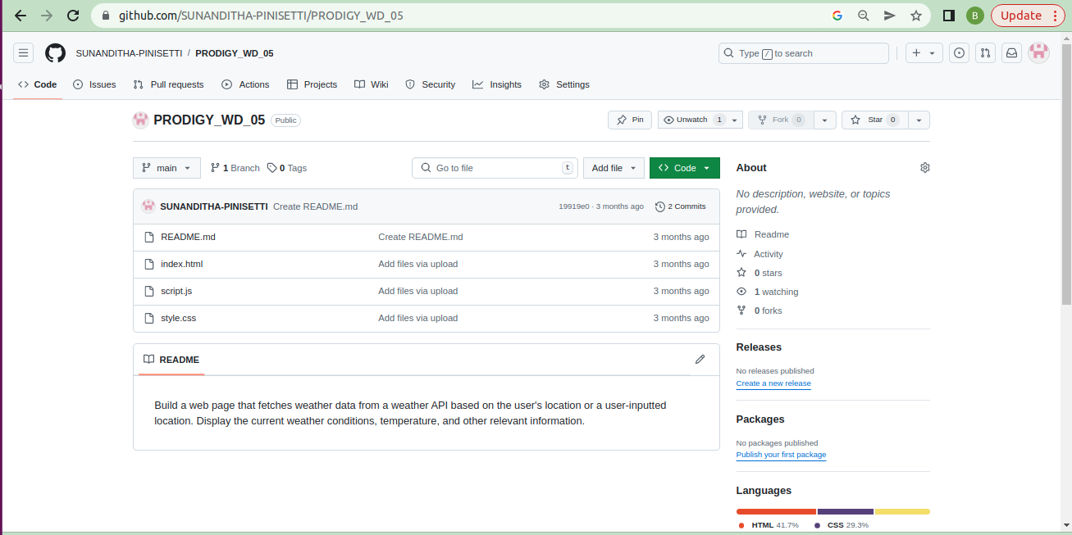
5. create a reposiyory to store your work.

That's it! You now have a Git profile set up, and optionally, a GitHub profile.

